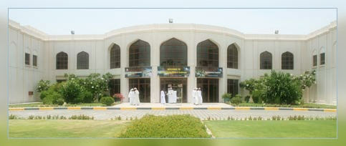

Design Phase

Room Scheduling System

**2008**

Done By:

Mohamed Omar Al Habshi 200200874

Mohamed Mohsen Al Amoudi 200200640

Done For:

ADMC Student Service

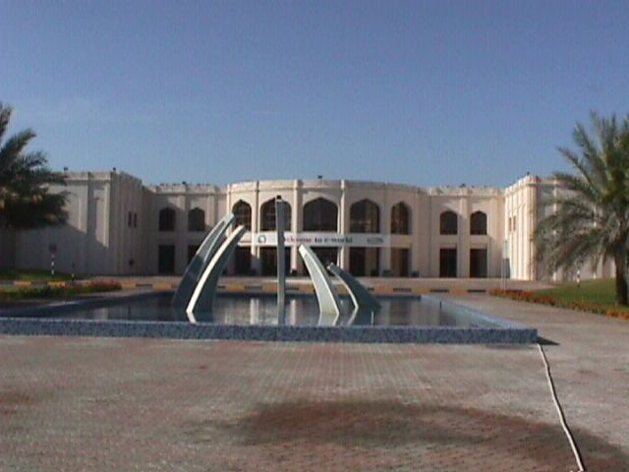

Introduction 3

Database Model 4

Entity Relation Diagram (ERD) 4

Entity Description 5

Schema 5

SQL Script 10

User Site Map 31

System Layout 32

System Security 36

Project Plan 38

Recommendation 39

Introduction

Design Phase is based on the information that has been collected from the analysis phase. In this phase we will create the ERD and we will describe every one of them. This phase will provide us with database structure and the backbone for our system which is very important.

We (Mohamed Omar & Mohamed Mohsen) will work hard to complete this project and to get the best information from it. In this report I will provide you with the SQL script for our database and screen shots for the system.

In this report we will include:

1. Database Model
2. Entity Description
3. Schema
4. SQL Script
5. Users Site Map
6. System Layouts
7. Validations for every layout
8. System Security
9. Project Plan

Database Model

Entity Relation Diagram (ERD)

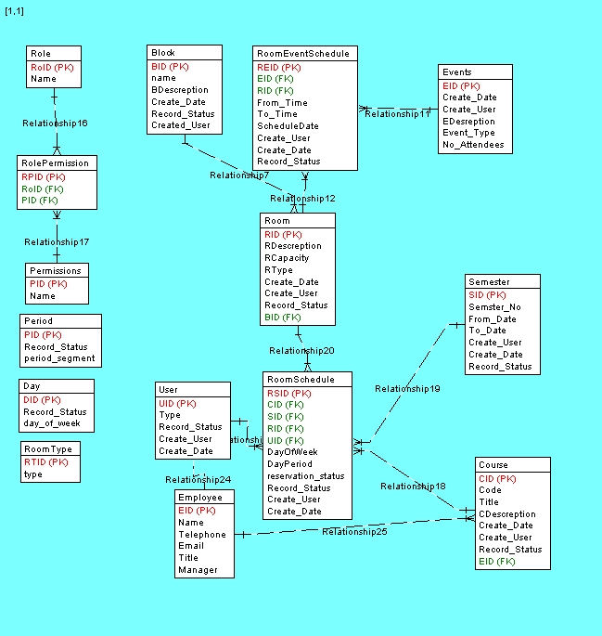

Entity Description

|  |  |
| --- | --- |
| **Entity** | **Description** |
| Course | Contain the course code, title and description |
| Semester | Provides the semester number and date |
| Room | Help to know the information about a room and the capacity |
| User | Provide the type of the user entered the system |
| Employee | Have all the information for the user (name, telephone, email) |
| Room Schedule | That’s the decomposed between all the previous Entities |
| Events | Include the event ID and type and description |
| Room Event Schedule | Information about the time of the event |
| Block | All the information about the block and the created date for it |
| Role | Role name only |
| Permission | Permission name only |
| Role Permission | The decomposed table between the previous two |
| Period | Contain the period segment and the status |
| Day | Record the day of the week to know it in the system |
| Room Type | Specify which type this room is |

Schema

**Course:**

|  |  |  |  |
| --- | --- | --- | --- |
| **Name** | **Type** | **Characteristic** | **Key** |
| CID | Char(5) | Unique Not Null | Primary Key |
| Code | Char(30) | Not Null |  |
| Title | Char(20) | Not Null |  |
| CDescription | Char(20) | Not Null |  |
| Create_Date | Date | Not Null |  |
| Create_User | Char(20) | Not Null |  |
| Record_Status | Char(20) | Not Null |  |
| EID | Char(5) | Not Null | Foreign Key |

**Semester:**

|  |  |  |  |
| --- | --- | --- | --- |
| **Name** | **Type** | **Characteristic** | **Key** |
| SID | Char(5) | Unique Not Null | Primary Key |
| Semester_No | Integer | Not Null |  |
| From_Date | Date | Not Null |  |
| To_Date | Date | Not Null |  |
| Create_User | Char(20) | Not Null |  |
| Create_Date | Char(20) | Not Null |  |
| Record_Status | Char(20) | Not Null |  |

**Room:**

|  |  |  |  |
| --- | --- | --- | --- |
| **Name** | **Type** | **Characteristic** | **Key** |
| RID | Char(5) | Unique Not Null | Primary Key |
| RDescription | Text | Not Null |  |
| RCapacity | Integer | Not Null |  |
| RType | Char(20) | Not Null |  |
| Create_Date | Date | Not Null |  |
| Create_User | Char(20) | Not Null |  |
| Record_Status | Char(20) | Not Null |  |
| BID | Char(5) | Not Null | Foreign Key |

**User:**

|  |  |  |  |
| --- | --- | --- | --- |
| **Name** | **Type** | **Characteristic** | **Key** |
| UID | Char(5) | Unique Not Null | Primary Key |
| Type | Char(5) | Not Null |  |
| Record_Status | Char(20) | Not Null |  |
| Create_User | Char(20) | Not Null |  |
| Create_Date | Date | Not Null |  |

**Employee:**

|  |  |  |  |
| --- | --- | --- | --- |
| **Name** | **Type** | **Characteristic** | **Key** |
| EID | Char(5) | Not Null | Primary Key |
| Name | Char(20) | Not Null |  |
| Telephone | Integer | Not Null |  |
| Email | Varchar(20) | Not Null |  |
| Title | Char(20) | Not Null |  |
| Manager | Char(20) | Not Null |  |

**Room Schedule:**

|  |  |  |  |
| --- | --- | --- | --- |
| **Name** | **Type** | **Characteristic** | **Key** |
| RSID | Char(5) | Not Null | Primary Key |
| CID | Char(5) | Not Null | Foreign Key |
| SID | Char(5) | Not Null | Foreign Key |
| RID | Char(5) | Not Null | Foreign Key |
| UID | Char(5) | Not Null | Foreign Key |
| DayOfWeek | Char(5) | Not Null |  |
| DayPeriod | Integer | Not Null |  |
| Reservation_Status | Varchar(12) | Not Null |  |
| Record_Status | Char(20) | Not Null |  |
| Create_User | Char(20) | Not Null |  |
| Create_Date | Date | Not Null |  |

**Events:**

|  |  |  |  |
| --- | --- | --- | --- |
| **Name** | **Type** | **Characteristic** | **Key** |
| EID | Char(5) | Unique Not Null | Primary Key |
| Create_Date | Date | Not Null |  |
| Create_User | Char(20) | Not Null |  |
| EDescription | Char(20) | Null |  |
| Event_Type | Char(20) | Not Null |  |
| No_Attendees | Char(20) | Not Null |  |

**Room Event Schedule:**

|  |  |  |  |
| --- | --- | --- | --- |
| **Name** | **Type** | **Characteristic** | **Key** |
| REID | Char(5) | Unique Not Null | Primary Key |
| EID | Char(5) | Not Null | Foreign Key |
| RID | Char(5) | Not Null | Foreign Key |
| From_Time | Char(20) | Not Null |  |
| To_Time | Char(20) | Not Null |  |
| ScheduleDate | Date | Not Null |  |
| Create_User | Char(20) | Not Null |  |
| Create_Date | Char(20) | Not Null |  |
| Record_Status | Char(20) | Not Null |  |

**Block:**

|  |  |  |  |
| --- | --- | --- | --- |
| **Name** | **Type** | **Characteristic** | **Key** |
| BID | Char(5) | Not Null | Primary Key |
| Name | Varchar(20) | Not Null |  |
| BDescription | Text | Not Null |  |
| Create_Date | Date | Not Null |  |
| Record_Status | Char(20) | Not Null |  |
| Create_User | Char(20) | Not Null |  |

**Role:**

|  |  |  |  |
| --- | --- | --- | --- |
| **Name** | **Type** | **Characteristic** | **Key** |
| ROID | Char(5) | Unique Not Null | Primary Key |
| Name | Char(20) | Not Null |  |

**Permission:**

|  |  |  |  |
| --- | --- | --- | --- |
| **Name** | **Type** | **Characteristic** | **Key** |
| PID | Char(5) | Unique Not Null | Primary Key |
| Name | Varchar(20) | Not Null |  |

**Role Permission:**

|  |  |  |  |
| --- | --- | --- | --- |
| **Name** | **Type** | **Characteristic** | **Key** |
| RPID | Char(5) | Not Null | Primary Key |
| ROID | Char(5) | Not Null | Foreign Key |
| PID | Char(5) | Not Null | Foreign Key |

**Period:**

|  |  |  |  |
| --- | --- | --- | --- |
| **Name** | **Type** | **Characteristic** | **Key** |
| PID | Char(5) | Unique Not Null | Primary Key |
| Record_Status | Char(20) | Not Null |  |
| Period_Segment | Char(20) | Not Null |  |

**Day:**

|  |  |  |  |
| --- | --- | --- | --- |
| **Name** | **Type** | **Characteristic** | **Key** |
| DID | Char(5) | Unique Not Null | Primary Key |
| Record_Status | Char(20) | Not Null |  |
| Day_of_Week | Char(20) | Not Null |  |

**Room Type:**

|  |  |  |  |
| --- | --- | --- | --- |
| **Name** | **Type** | **Characteristic** | **Key** |
| RTID | Char(5) | Not Null | Primary Key |
| Type | Varchar(20) | Not Null |  |

SQL Script

/*

SQLyog Community Edition- MySQL GUI v5.22a

Host - 5.0.27-community-nt : Database - room_scheduling_system

*********************************************************************

Server version : 5.0.27-community-nt

*/

/*!40101 SET NAMES utf8 */;

/*!40101 SET SQL_MODE=''*/;

create database if not exists `room_scheduling_system`;

USE `room_scheduling_system`;

/*!40014 SET @OLD_FOREIGN_KEY_CHECKS=@@FOREIGN_KEY_CHECKS, FOREIGN_KEY_CHECKS=0 */;

/*!40101 SET @OLD_SQL_MODE=@@SQL_MODE, SQL_MODE='NO_AUTO_VALUE_ON_ZERO' */;

/*Table structure for table `block` */

DROP TABLE IF EXISTS `block`;

CREATE TABLE `block` (

`id` int(11) NOT NULL auto_increment,

`create_date` datetime default NULL,

`record_status` varchar(255) default NULL,

`description` varchar(255) default NULL,

`name` varchar(255) default NULL,

`create_user` int(11) default NULL,

PRIMARY KEY (`id`),

KEY `FK597C48DE85A148D` (`create_user`),

CONSTRAINT `FK597C48DE85A148D` FOREIGN KEY (`create_user`) REFERENCES `system_user` (`id`)

) ENGINE=InnoDB DEFAULT CHARSET=utf8;

/*Data for the table `block` */

insert into `block`(`id`,`create_date`,`record_status`,`description`,`name`,`create_user`) values (1,NULL,'Active','This is the TWing','T Wing',NULL),(2,NULL,'Active','Electronic Wing','E Wing',NULL);

/*Table structure for table `course` */

DROP TABLE IF EXISTS `course`;

CREATE TABLE `course` (

`id` int(11) NOT NULL auto_increment,

`create_date` datetime default NULL,

`record_status` varchar(255) default NULL,

`code` varchar(255) default NULL,

`description` varchar(255) default NULL,

`title` varchar(255) default NULL,

`create_user` int(11) default NULL,

PRIMARY KEY (`id`),

KEY `FKAF42E01BE85A148D` (`create_user`),

CONSTRAINT `FKAF42E01BE85A148D` FOREIGN KEY (`create_user`) REFERENCES `system_user` (`id`)

) ENGINE=InnoDB DEFAULT CHARSET=utf8;

/*Data for the table `course` */

insert into `course`(`id`,`create_date`,`record_status`,`code`,`description`,`title`,`create_user`) values (1,NULL,NULL,'ITEC 150','Course Description','Programming',NULL),(2,NULL,NULL,'CNET 360','Networking Course where student will gain abilities to build networks','Networking',NULL);

/*Table structure for table `employee` */

DROP TABLE IF EXISTS `employee`;

CREATE TABLE `employee` (

`id` int(11) NOT NULL auto_increment,

`create_date` datetime default NULL,

`record_status` varchar(255) default NULL,

`email` varchar(255) default NULL,

`first_name` varchar(255) default NULL,

`last_name` varchar(255) default NULL,

`telephone` varchar(255) default NULL,

`create_user` int(11) default NULL,

`manager` int(11) default NULL,

PRIMARY KEY (`id`),

KEY `FK4722E6AEAF53F3EF` (`manager`),

KEY `FK4722E6AEE85A148D` (`create_user`),

CONSTRAINT `FK4722E6AEAF53F3EF` FOREIGN KEY (`manager`) REFERENCES `employee` (`id`),

CONSTRAINT `FK4722E6AEE85A148D` FOREIGN KEY (`create_user`) REFERENCES `system_user` (`id`)

) ENGINE=InnoDB DEFAULT CHARSET=utf8;

/*Data for the table `employee` */

insert into `employee`(`id`,`create_date`,`record_status`,`email`,`first_name`,`last_name`,`telephone`,`create_user`,`manager`) values (1,NULL,NULL,NULL,'Mohamed',NULL,NULL,NULL,2),(2,NULL,NULL,NULL,NULL,NULL,NULL,NULL,NULL);

/*Table structure for table `employee_course` */

DROP TABLE IF EXISTS `employee_course`;

CREATE TABLE `employee_course` (

`teacher_id` int(11) NOT NULL,

`courses_id` int(11) NOT NULL,

PRIMARY KEY (`teacher_id`,`courses_id`),

KEY `FK8ADB6CC366966DA` (`teacher_id`),

KEY `FK8ADB6CC1D7A45B1` (`courses_id`),

CONSTRAINT `FK8ADB6CC1D7A45B1` FOREIGN KEY (`courses_id`) REFERENCES `course` (`id`),

CONSTRAINT `FK8ADB6CC366966DA` FOREIGN KEY (`teacher_id`) REFERENCES `employee` (`id`)

) ENGINE=InnoDB DEFAULT CHARSET=utf8;

/*Data for the table `employee_course` */

insert into `employee_course`(`teacher_id`,`courses_id`) values (1,1);

/*Table structure for table `event` */

DROP TABLE IF EXISTS `event`;

CREATE TABLE `event` (

`id` int(11) NOT NULL auto_increment,

`create_date` datetime default NULL,

`record_status` varchar(255) default NULL,

`login_name` int(11) default NULL,

`description` varchar(255) default NULL,

`event_type` int(11) default NULL,

`create_user` int(11) default NULL,

PRIMARY KEY (`id`),

KEY `FK5C6729AE85A148D` (`create_user`),

CONSTRAINT `FK5C6729AE85A148D` FOREIGN KEY (`create_user`) REFERENCES `system_user` (`id`)

) ENGINE=InnoDB DEFAULT CHARSET=utf8;

/*Data for the table `event` */

insert into `event`(`id`,`create_date`,`record_status`,`login_name`,`description`,`event_type`,`create_user`) values (1,NULL,NULL,0,'Event Description',NULL,NULL);

/*Table structure for table `period` */

DROP TABLE IF EXISTS `period`;

CREATE TABLE `period` (

`id` int(11) NOT NULL auto_increment,

`create_date` datetime default NULL,

`record_status` varchar(255) default NULL,

`period_segment` varchar(255) default NULL,

`create_user` int(11) default NULL,

PRIMARY KEY (`id`),

KEY `FKC4E375C1E85A148D` (`create_user`),

CONSTRAINT `FKC4E375C1E85A148D` FOREIGN KEY (`create_user`) REFERENCES `system_user` (`id`)

) ENGINE=InnoDB DEFAULT CHARSET=utf8;

/*Data for the table `period` */

insert into `period`(`id`,`create_date`,`record_status`,`period_segment`,`create_user`) values (1,NULL,NULL,'08:00 - 08:55',NULL),(2,NULL,NULL,'09:00 - 09:55',NULL),(3,NULL,NULL,'10:00 - 10:55',NULL),(4,NULL,NULL,'11:00 - 11:55',NULL),(5,NULL,NULL,'12:00 - 12:55',NULL),(6,NULL,NULL,'13:00 - 13:55',NULL),(7,NULL,NULL,'14:00 - 14:55',NULL),(8,NULL,NULL,'15:00 - 15:55',NULL),(9,NULL,NULL,'16:00 - 16:55',NULL),(10,NULL,NULL,'17:00 - 17:55',NULL),(11,NULL,NULL,'18:00 - 18:55',NULL),(12,NULL,NULL,'19:00 - 19:55',NULL);

/*Table structure for table `permission` */

DROP TABLE IF EXISTS `permission`;

CREATE TABLE `permission` (

`id` int(11) NOT NULL auto_increment,

`create_date` datetime default NULL,

`record_status` varchar(255) default NULL,

`description` varchar(255) default NULL,

`create_user` int(11) default NULL,

PRIMARY KEY (`id`),

KEY `FKE125C5CFE85A148D` (`create_user`),

CONSTRAINT `FKE125C5CFE85A148D` FOREIGN KEY (`create_user`) REFERENCES `system_user` (`id`)

) ENGINE=InnoDB DEFAULT CHARSET=utf8;

/*Data for the table `permission` */

insert into `permission`(`id`,`create_date`,`record_status`,`description`,`create_user`) values (1,NULL,NULL,'Create Event',NULL);

/*Table structure for table `role` */

DROP TABLE IF EXISTS `role`;

CREATE TABLE `role` (

`id` int(11) NOT NULL auto_increment,

`create_date` datetime default NULL,

`record_status` varchar(255) default NULL,

`description` varchar(255) default NULL,

`create_user` int(11) default NULL,

PRIMARY KEY (`id`),

KEY `FK358076E85A148D` (`create_user`),

CONSTRAINT `FK358076E85A148D` FOREIGN KEY (`create_user`) REFERENCES `system_user` (`id`)

) ENGINE=InnoDB DEFAULT CHARSET=utf8;

/*Data for the table `role` */

insert into `role`(`id`,`create_date`,`record_status`,`description`,`create_user`) values (1,NULL,NULL,'Admin',NULL);

/*Table structure for table `role_permission` */

DROP TABLE IF EXISTS `role_permission`;

CREATE TABLE `role_permission` (

`roles_id` int(11) NOT NULL,

`permissions_id` int(11) NOT NULL,

PRIMARY KEY (`roles_id`,`permissions_id`),

KEY `FKBD40D538F5ED75E7` (`roles_id`),

KEY `FKBD40D538C7DAAD19` (`permissions_id`),

CONSTRAINT `FKBD40D538C7DAAD19` FOREIGN KEY (`permissions_id`) REFERENCES `permission` (`id`),

CONSTRAINT `FKBD40D538F5ED75E7` FOREIGN KEY (`roles_id`) REFERENCES `role` (`id`)

) ENGINE=InnoDB DEFAULT CHARSET=utf8;

/*Data for the table `role_permission` */

insert into `role_permission`(`roles_id`,`permissions_id`) values (1,1);

/*Table structure for table `room` */

DROP TABLE IF EXISTS `room`;

CREATE TABLE `room` (

`id` int(11) NOT NULL auto_increment,

`create_date` datetime default NULL,

`record_status` varchar(255) default NULL,

`capacity` varchar(255) default NULL,

`description` varchar(255) default NULL,

`create_user` int(11) default NULL,

`block_id` int(11) default NULL,

`room_type` int(11) default NULL,

`name` varchar(255) default NULL,

PRIMARY KEY (`id`),

KEY `FK3580DBE85A148D` (`create_user`),

KEY `FK3580DB8A2A1586` (`block_id`),

KEY `FK3580DBEC74B467` (`room_type`),

CONSTRAINT `FK3580DB8A2A1586` FOREIGN KEY (`block_id`) REFERENCES `block` (`id`),

CONSTRAINT `FK3580DBE85A148D` FOREIGN KEY (`create_user`) REFERENCES `system_user` (`id`),

CONSTRAINT `FK3580DBEC74B467` FOREIGN KEY (`room_type`) REFERENCES `room_type` (`id`)

) ENGINE=InnoDB DEFAULT CHARSET=utf8;

/*Data for the table `room` */

insert into `room`(`id`,`create_date`,`record_status`,`capacity`,`description`,`create_user`,`block_id`,`room_type`,`name`) values (1,NULL,'Active','8','Engineering Room',NULL,1,1,'T001'),(2,NULL,'Active','8','Another Lab',NULL,1,1,'E-090'),(3,NULL,'Active','80','descx',1,2,1,'Z-090'),(4,NULL,'Active','9','TWing Lab',NULL,2,1,'Z-090'),(7,NULL,'Deleted','90','asd',NULL,1,1,'A-095'),(8,NULL,'Active','7','desc',1,2,1,'X202'),(9,NULL,'Active','8','iuefiuyguy',1,2,1,'R08');

/*Table structure for table `room_class_schedule` */

DROP TABLE IF EXISTS `room_class_schedule`;

CREATE TABLE `room_class_schedule` (

`id` int(11) NOT NULL auto_increment,

`create_date` datetime default NULL,

`record_status` varchar(255) default NULL,

`day_of_week` int(11) default NULL,

`reservation_status` varchar(255) default NULL,

`create_user` int(11) default NULL,

`course` int(11) default NULL,

`period` int(11) default NULL,

`reserver` int(11) default NULL,

`room` int(11) default NULL,

`semester` int(11) default NULL,

`semester_week` int(11) default NULL,

PRIMARY KEY (`id`),

KEY `FK8C30FD62383812CA` (`course`),

KEY `FK8C30FD62F0E25E95` (`reserver`),

KEY `FK8C30FD62C7EC2004` (`semester`),

KEY `FK8C30FD62E85A148D` (`create_user`),

KEY `FK8C30FD625F8E94A` (`room`),

KEY `FK8C30FD6263793E16` (`period`),

CONSTRAINT `FK8C30FD62383812CA` FOREIGN KEY (`course`) REFERENCES `course` (`id`),

CONSTRAINT `FK8C30FD625F8E94A` FOREIGN KEY (`room`) REFERENCES `room` (`id`),

CONSTRAINT `FK8C30FD6263793E16` FOREIGN KEY (`period`) REFERENCES `period` (`id`),

CONSTRAINT `FK8C30FD62C7EC2004` FOREIGN KEY (`semester`) REFERENCES `semester` (`id`),

CONSTRAINT `FK8C30FD62E85A148D` FOREIGN KEY (`create_user`) REFERENCES `system_user` (`id`),

CONSTRAINT `FK8C30FD62F0E25E95` FOREIGN KEY (`reserver`) REFERENCES `system_user` (`id`)

) ENGINE=InnoDB DEFAULT CHARSET=utf8;

/*Data for the table `room_class_schedule` */

insert into `room_class_schedule`(`id`,`create_date`,`record_status`,`day_of_week`,`reservation_status`,`create_user`,`course`,`period`,`reserver`,`room`,`semester`,`semester_week`) values (1,NULL,NULL,1,'pending',NULL,1,1,1,1,1,1),(12,NULL,'Active',4,'pending',NULL,1,1,NULL,1,1,1),(13,NULL,'Active',6,'pending',NULL,1,1,NULL,1,1,1),(14,NULL,'Active',3,'pending',NULL,1,4,NULL,1,1,20),(15,NULL,'Active',3,'pending',NULL,1,7,NULL,1,1,20),(16,NULL,'Active',2,'pending',NULL,2,1,NULL,1,1,20),(17,NULL,'Active',1,'pending',NULL,2,2,NULL,1,1,20),(18,NULL,'Active',1,'pending',NULL,2,12,NULL,1,1,20),(19,NULL,'Active',2,'pending',NULL,2,12,NULL,1,1,20),(20,NULL,'Active',3,'pending',NULL,2,12,NULL,1,1,20),(21,NULL,'Active',4,'pending',NULL,2,12,NULL,1,1,20),(22,NULL,'Active',5,'pending',NULL,2,12,NULL,1,1,20),(23,NULL,'Active',6,'pending',NULL,2,12,NULL,1,1,20),(24,NULL,'Active',1,'pending',NULL,1,10,NULL,1,1,20),(25,NULL,'Active',2,'pending',NULL,1,10,NULL,1,1,20),(26,NULL,'Active',5,'pending',NULL,2,9,NULL,1,1,20),(27,NULL,'Active',6,'pending',NULL,2,9,NULL,1,1,20),(28,NULL,'Active',1,'pending',NULL,2,10,NULL,1,1,20),(29,NULL,'Active',2,'pending',NULL,2,10,NULL,1,1,20),(30,NULL,'Active',1,'pending',1,1,1,NULL,1,1,20),(31,NULL,'Active',1,'accepted',NULL,1,1,NULL,1,1,21),(32,NULL,'Active',1,'pending',NULL,1,2,NULL,1,1,21),(33,NULL,'Active',2,'accepted',NULL,2,3,NULL,1,1,21),(34,NULL,'Active',3,'pending',NULL,2,3,NULL,1,1,21),(35,NULL,'Active',4,'accepted',NULL,2,3,NULL,1,1,21),(36,NULL,'Active',5,'pending',NULL,2,4,NULL,1,1,21),(37,NULL,'Active',2,'accepted',NULL,2,5,NULL,1,1,21),(38,NULL,'Active',3,'pending',NULL,2,5,NULL,1,1,21),(39,NULL,'Active',6,'accepted',NULL,2,5,NULL,1,1,21),(40,NULL,'Active',1,'pending',NULL,2,6,NULL,1,1,21),(41,NULL,'Active',3,'pending',NULL,2,6,NULL,1,1,21),(42,NULL,'Active',4,'accepted',NULL,2,6,NULL,1,1,21),(43,NULL,'Active',6,'pending',NULL,2,6,NULL,1,1,21),(44,NULL,'Active',1,'accepted',NULL,2,7,NULL,1,1,21),(45,NULL,'Active',3,'accepted',NULL,2,7,NULL,1,1,21),(46,NULL,'Active',6,'accepted',NULL,2,7,NULL,1,1,21),(47,NULL,'Active',1,'pending',NULL,2,8,NULL,1,1,21),(48,NULL,'Active',5,'pending',NULL,2,8,NULL,1,1,21),(49,NULL,'Active',2,'accepted',NULL,2,9,NULL,1,1,21),(50,NULL,'Active',3,'pending',NULL,2,9,NULL,1,1,21),(51,NULL,'Active',4,'accepted',NULL,2,9,NULL,1,1,21),(52,NULL,'Active',4,'pending',NULL,2,7,NULL,1,1,21),(125,NULL,'Active',6,'pending',1,1,1,1,1,1,1),(126,NULL,'Active',6,'pending',1,1,1,1,1,1,2),(127,NULL,'Active',6,'pending',1,1,1,1,1,1,3),(128,NULL,'Active',6,'pending',1,1,1,1,1,1,4),(129,NULL,'Active',6,'pending',1,1,1,1,1,1,5),(130,NULL,'Active',6,'pending',1,1,1,1,1,1,6),(131,NULL,'Active',6,'pending',1,1,1,1,1,1,7),(132,NULL,'Active',6,'pending',1,1,1,1,1,1,8),(133,NULL,'Active',6,'pending',1,1,1,1,1,1,9),(134,NULL,'Active',6,'pending',1,1,1,1,1,1,10),(135,NULL,'Active',6,'pending',1,1,1,1,1,1,11),(136,NULL,'Active',6,'pending',1,1,1,1,1,1,12),(137,NULL,'Active',6,'pending',1,1,1,1,1,1,13),(138,NULL,'Active',6,'pending',1,1,1,1,1,1,14),(139,NULL,'Active',6,'pending',1,1,1,1,1,1,15),(140,NULL,'Active',6,'pending',1,1,1,1,1,1,16),(141,NULL,'Active',6,'pending',1,1,1,1,1,1,17),(142,NULL,'Active',6,'pending',1,1,1,1,1,1,18),(143,NULL,'Active',6,'pending',1,1,1,1,1,1,19),(144,NULL,'Active',6,'pending',1,1,1,1,1,1,20),(145,NULL,'Active',6,'pending',1,1,1,1,1,1,21),(146,NULL,'Active',6,'pending',1,1,1,1,1,1,22),(147,NULL,'Active',6,'pending',1,2,2,1,1,1,20),(148,NULL,'Active',6,'pending',1,2,3,1,1,1,20),(149,NULL,'Active',1,'accepted',1,2,11,1,1,1,21);

/*Table structure for table `room_event_schedule` */

DROP TABLE IF EXISTS `room_event_schedule`;

CREATE TABLE `room_event_schedule` (

`id` int(11) NOT NULL auto_increment,

`create_date` datetime default NULL,

`record_status` varchar(255) default NULL,

`schedule_date` date default NULL,

`create_user` int(11) default NULL,

`event` int(11) default NULL,

`from_time` int(11) default NULL,

`room` int(11) default NULL,

`to_time` int(11) default NULL,

PRIMARY KEY (`id`),

KEY `FKCBA35A80A364F697` (`from_time`),

KEY `FKCBA35A80B7BBF020` (`event`),

KEY `FKCBA35A80E85A148D` (`create_user`),

KEY `FKCBA35A8059C39A66` (`to_time`),

KEY `FKCBA35A805F8E94A` (`room`),

CONSTRAINT `FKCBA35A8059C39A66` FOREIGN KEY (`to_time`) REFERENCES `period` (`id`),

CONSTRAINT `FKCBA35A805F8E94A` FOREIGN KEY (`room`) REFERENCES `room` (`id`),

CONSTRAINT `FKCBA35A80A364F697` FOREIGN KEY (`from_time`) REFERENCES `period` (`id`),

CONSTRAINT `FKCBA35A80B7BBF020` FOREIGN KEY (`event`) REFERENCES `event` (`id`),

CONSTRAINT `FKCBA35A80E85A148D` FOREIGN KEY (`create_user`) REFERENCES `system_user` (`id`)

) ENGINE=InnoDB DEFAULT CHARSET=utf8;

/*Data for the table `room_event_schedule` */

insert into `room_event_schedule`(`id`,`create_date`,`record_status`,`schedule_date`,`create_user`,`event`,`from_time`,`room`,`to_time`) values (1,NULL,NULL,NULL,NULL,1,NULL,1,NULL);

/*Table structure for table `room_type` */

DROP TABLE IF EXISTS `room_type`;

CREATE TABLE `room_type` (

`id` int(11) NOT NULL auto_increment,

`create_date` datetime default NULL,

`record_status` varchar(255) default NULL,

`type` varchar(255) default NULL,

`create_user` int(11) default NULL,

PRIMARY KEY (`id`),

KEY `FKC061181EE85A148D` (`create_user`),

CONSTRAINT `FKC061181EE85A148D` FOREIGN KEY (`create_user`) REFERENCES `system_user` (`id`)

) ENGINE=InnoDB DEFAULT CHARSET=utf8;

/*Data for the table `room_type` */

insert into `room_type`(`id`,`create_date`,`record_status`,`type`,`create_user`) values (1,NULL,NULL,'Lab',NULL);

/*Table structure for table `semester` */

DROP TABLE IF EXISTS `semester`;

CREATE TABLE `semester` (

`id` int(11) NOT NULL auto_increment,

`create_date` datetime default NULL,

`record_status` varchar(255) default NULL,

`date_from` date default NULL,

`date_to` date default NULL,

`semester_no` varchar(255) default NULL,

`create_user` int(11) default NULL,

PRIMARY KEY (`id`),

KEY `FK48C21138E85A148D` (`create_user`),

CONSTRAINT `FK48C21138E85A148D` FOREIGN KEY (`create_user`) REFERENCES `system_user` (`id`)

) ENGINE=InnoDB DEFAULT CHARSET=utf8;

/*Data for the table `semester` */

insert into `semester`(`id`,`create_date`,`record_status`,`date_from`,`date_to`,`semester_no`,`create_user`) values (1,NULL,NULL,'2008-01-01','2008-06-01','1',NULL);

/*Table structure for table `system_user` */

DROP TABLE IF EXISTS `system_user`;

CREATE TABLE `system_user` (

`id` int(11) NOT NULL auto_increment,

`create_date` datetime default NULL,

`record_status` varchar(255) default NULL,

`login_name` varchar(255) default NULL,

`login_password` varchar(255) default NULL,

`create_user` int(11) default NULL,

`role` int(11) default NULL,

PRIMARY KEY (`id`),

KEY `FKA48037DB5F8E880` (`role`),

KEY `FKA48037DBE85A148D` (`create_user`),

CONSTRAINT `FKA48037DB5F8E880` FOREIGN KEY (`role`) REFERENCES `role` (`id`),

CONSTRAINT `FKA48037DBE85A148D` FOREIGN KEY (`create_user`) REFERENCES `system_user` (`id`)

) ENGINE=InnoDB DEFAULT CHARSET=utf8;

/*Data for the table `system_user` */

insert into `system_user`(`id`,`create_date`,`record_status`,`login_name`,`login_password`,`create_user`,`role`) values (1,NULL,NULL,'Ali','123456',NULL,1);

/*!40101 SET SQL_MODE=@OLD_SQL_MODE */;

/*!40014 SET FOREIGN_KEY_CHECKS=@OLD_FOREIGN_KEY_CHECKS */;

User Site Map

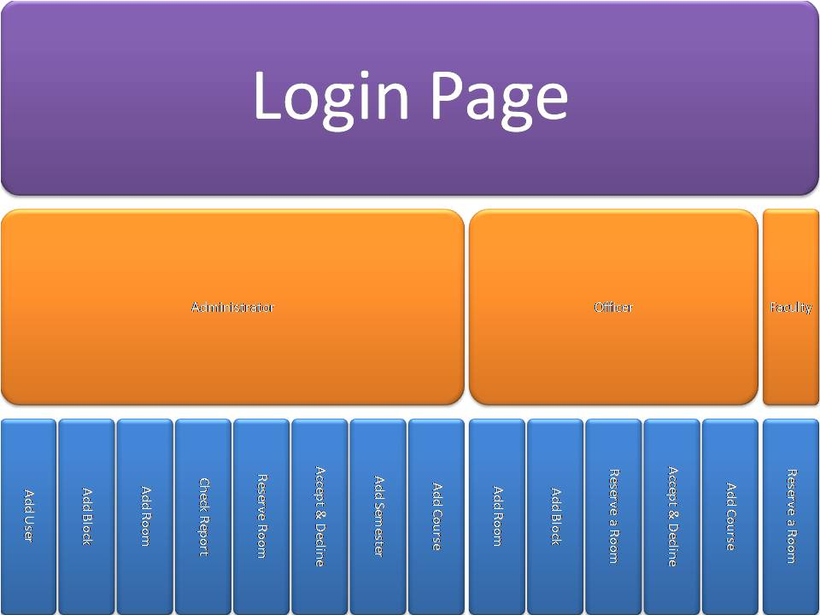

System Layout

In this section I will present a prototype about our system just to clarify every idea in the system and to show something for the client. We will not include all the pages in this phase because it is only a prototype.

**Add Block Page:**

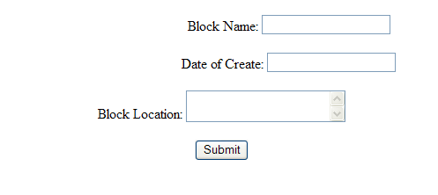

This small form will provide you with the ability to add block any time you want to. It is a small form which is easy for the user to understand and I will explain every field in it in the table below:

|  |  |  |
| --- | --- | --- |
| Field Name | Description | Validation |
| Block Name | To specify the block name | Cannot be empty |
| Date of Create | To specify the created date | Cannot be empty  Must be a date |
| Block Location | Provide the location of the block | cannot be empty |

**Add Room Page:**

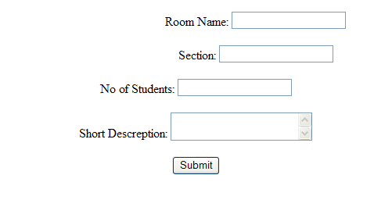

This page will help you to add rooms for the college because the college will continue to add rooms till the end of life. We will provide you with the fields’ description and the validation for it in the table below:

|  |  |  |
| --- | --- | --- |
| Field Name | Description | Validation |
| Room Name | To specify the room name | Cannot be empty |
| Section | To specify the Section which is for (IT, Chemical) | Cannot be empty |
| No of Students | The capacity to fit this room | cannot be empty  must be a number |
| Short description | Write what does this room have | Cannot be empty |

**Log In Page:**

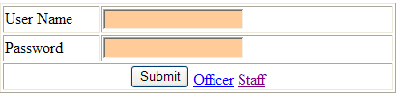

This page is the first page in the system which asks for the username and the password to specify the type of the user you are. The validation for this form is that the username cannot be empty and it must be already in the database. The password must match the password in the database.

**Room Page:**

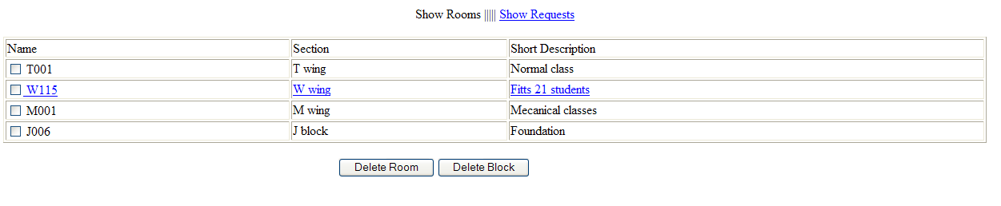This page shows the rooms that can be reserved. You notice that this user is an officer because he/she has the ability to delete a room or delete a block. The tab above shows that there is another page for the officer to check the requests that came from the faculty.

**Request Page:**

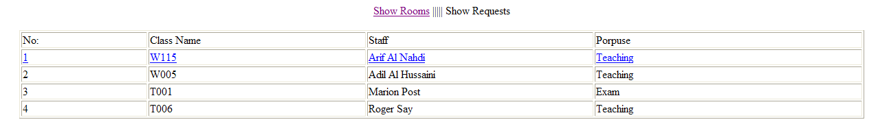

This page shows the requests for the officer with the teacher name and the propose for reserving this room. The officers just have to click on any link from that row to enter the schedule and chose to decline or accept.

**Schedule Page:**

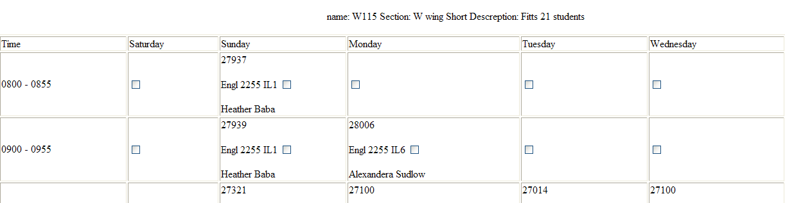

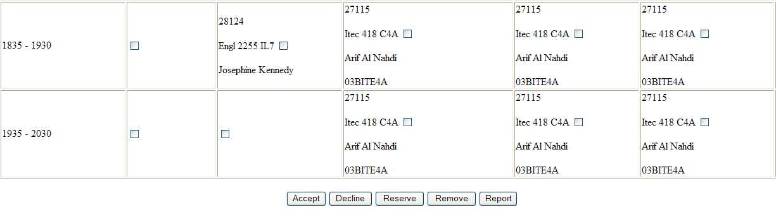

This page is very big so we have to divide it into two pictures to show it to you. The officer will check the room schedule and will see the requested room colored so he/she will has to select a check box then press accept or decline so an email will be send to the reserved user.

System Security

In this section we will talk about every user and the roles that he/she can do

**Administrator:**

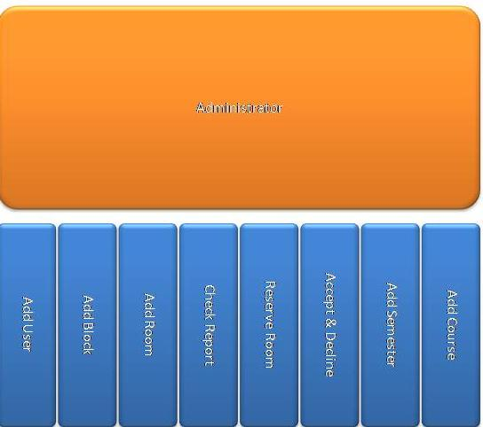

The Administrator can do:

1. Add User 2- Add Block 3- Add Room

4- Check Report 5- Reserve a Room

6- Accept & Reject a room 7- Add Course

8- Add Semester

**Officer:**

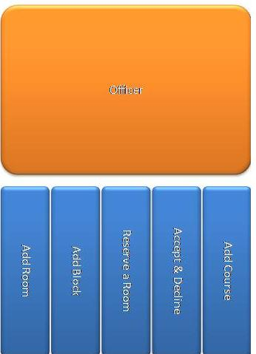

The officer can do:

1. Add Room
2. Add Block
3. Reserve a Room
4. Accept & reject a room
5. Add Course

**Faculty:**

The faculty only can reserve a room or an event

Project Plan

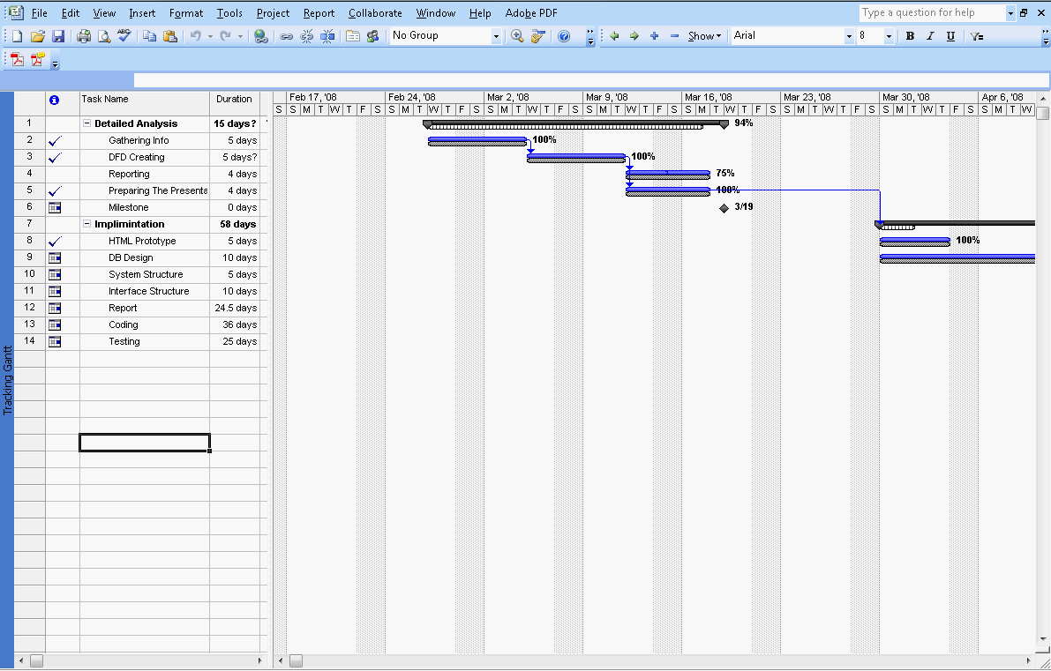

Recommendation

At the end we notice that when we move forward the project became easier. The best thing we have done at this phase is creating a prototype of our system and we show it to Mr. Khalid Abdulla. This shows us the right thing to do and to avoid the things that he dislikes to create the best system for the academic services.

Our next phase will be the implementation phase which is the last phase. In this system.We have to hard code everything then we will provide our project to the academic services after showing them how to install the system.

